ORIGINAL RESEARCH GERIATRIC ANESTHESIA
Co-induction with phenylephrine–propofol in elderly patients during LMA anesthesia for prevention of hypotension; a randomized double-blind trial
Hien Van Vo ¹, Quynh Van Nguyen ², Thang Xuan Vy ³, Anh Ngoc Le ⁴, Hung Phi Tran ⁵
Authors affiliations:
1. Hien Van Vo, Department of Anesthesia, Le Huu Trac National Burn Hospital, Hanoi, Vietnam; Department of Anesthesia, Vietnam Military Medical University, Hanoi, Vietnam; Email: vanhien@vmmu.edu.vn
2. Quynh Van Nguyen. Vietnam Military Medical University, Hanoi, Vietnam; Email: nguyenvanquynh304@gmail.com
3. Thang Xuan Vy. Department of Anesthesia, Le Huu Trac National Burn Hospital, Hanoi, Vietnam; Email: Email: thangvx.anes@gmail.com
4. Anh Ngoc Le, Department of Anesthesia, Le Huu Trac National Burn Hospital, Hanoi, Vietnam; Email: quangpro911@gmail.com
5. Hung Phi Tran, Department of Anesthesia, Le Huu Trac National Burn Hospital, Hanoi, Vietnam; Email: quanghung99pldl@gmail.com
Correspondence: Le Ngoc Anh, Email: quangro911@gmail.com; Phone: +84.94.6667797

ABSTRACT
Background and objective: Propofol-induced hypotension poses significant cardiovascular risks in elderly patients. This study evaluated the efficacy of co-administering phenylephrine with propofol to prevent hypotension during induction and laryngeal mask airway (LMA) insertion in elderly patients undergoing flap transfer surgery.
Methodology: This randomized, double-blind, controlled trial enrolled 90 elderly patients (≥60 years). Participants were assigned to receive a standardized 12 mL induction solution containing 100 mg propofol (10 mL) combined with either 50 µg (1mL) phenylephrine plus 1 mL 0.9% sodium chloride (Group 1); 100 µg phenylephrine (2mL) (Group 2), or 2 mL 0.9% sodium chloride (Group 3). Hemodynamics variables and vasopressor requirements were monitored for 10 minutes after induction.
Results: The incidence of hypotension was significantly lower in Group 2 (36.7%) compared to Group 3 (83.3%, p < 0.05), while Group 1 (63.3%) occupied an intermediate position. Correspondingly, Group 2 required the lowest rate of rescue treatment (20.0%), which was significantly lower than Group 3 (p < 0.001 for overall comparison; post-hoc p < 0.05). Notably, total cumulative phenylephrine consumption was statistically similar across all three groups (~100.0 µg, p = 0.993). Heart rate (HR) changes were comparable across groups.
Conclusion: A co-induction mixture consisting of propofol (100 mg/10 mL) combined with phenylephrine (100 µg/2 mL) - administered by titration to effect - effectively attenuates induction-related hypotension in elderly patients without increasing overall vasopressor requirements or adversely affecting heart rate.
Abbreviation: LMA: Laryngeal Mask Airway; HR: Heart Rate; SBP: Systolic Blood Pressure; DBP: Diastolic Blood Pressure; MAP: Mean Arterial Pressure; HRT: Hypotension Requiring Treatment.
Keywords: Phenylephrine; Hypotension; Elderly patients; Induction of anesthesia.
Citation: Vo HV, Nguyen QV, Vy TX, Le AN, Tran HP. Co-induction with phenylephrine–propofol in elderly patients during LMA anesthesia for prevention of hypotension; a randomized double-blind trial. Anaesth. pain intensive care 2026;30(4):487-492. DOI: 10.35975/apic.v30i4.3213
Received: January 10, 2026; Revised: April 01, 2026; Accepted: April 01, 2026

1. INTRODUCTION
The aging global population, together with advances in anesthesia and perioperative care, has led to a steady rise in the number of elderly patients requiring surgical

interventions. In developed countries, individuals aged ≥60 years now account for over half of all surgical procedures.¹⁻³ Anesthetic management in this population remains challenging due to age-related declines in physiological reserve, increased sensitivity to anesthetic agents, and a high burden of comorbidities, all of which elevate the risk of perioperative complications.^{1, 2, 4, 5}
Propofol remains the most commonly used intravenous induction agent due to its smooth induction profile, hemodynamic stability during maintenance, and rapid recovery characteristics. However, its most notable adverse effects include direct myocardial depression and vasodilation, frequently resulting in hypotension, with reported incidence rates ranging from 25% to 67.5%.⁶⁻⁸ This risk is particularly pronounced in the elderly; for instance, Takaki et al. reported hypotension rates of up to 72.7% in patients aged over 80 years during propofol induction.⁹ Post-induction hypotension is associated with severe adverse clinical outcomes, including acute kidney injury, myocardial injury, increased mortality rates, and prolonged postoperative hospitalization.^{10,11} Several preventive strategies have been proposed, including fluid optimization, slower injection techniques, dose reduction, and co-administration of vasopressors.^{12, 13} Phenylephrine, a synthetic non-catecholamine vasopressor, acts primarily as a direct α₁-adrenergic receptor agonist. Previous studies, including those by F.Y. Kwok (2016), Muhamad Imran (2015) )and Farhan (2015)… have demonstrated the pharmacological compatibility and clinical efficacy of a phenylephrine-propofol admixture in reducing the incidence of induction-related hypotension.^{8, 14, 15} However, there remains no clear consensus regarding the phenylephrine dose that provides effective prevention of hypotension while minimizing dose-related adverse effects, such as reflex bradycardia or excessive hypertension, particularly in the geriatric population.
Therefore, this study aimed to evaluate the effectiveness of propofol co-administered with different phenylephrine doses in preventing hypotension during induction and laryngeal mask airway insertion in elderly patients undergoing flap transfer surgery.
2. METHODOLOGY
A prospective, randomized, double-blind, controlled clinical trial study was conducted at Le Huu Trac National Burn Hospital (Vietnam Military Medical University), a tertiary referral center for burn care in Hanoi, Vietnam, between August 2024 and February 2025.
The study was approved by the Institutional Review Board of the Military Medical University (Decision No. 2237/QĐ-HVQY, dated June 14, 2024). All participants received a full explanation of the study protocol and provided written informed consent prior to enrollment. All ethical principles for medical research involving human subjects were strictly observed. Permission for data use and publication was granted by Le Huu Trac National Burn Hospital. The study was registered on the Research Registry on October 5, 2024, under the Unique Identifying Number: researchregistry10755. (https://www.researchregistry.com/browse-the registry/#home/registrationdetails/6700f35fcb65a602d3ab9d9f/)
Elderly patients scheduled for flap transfer surgery to treat sacral pressure ulcer under general anesthesia with LMA insertion. Patients aged 60 years or older; American Society of Anesthesiologists (ASA) physical status I, II or III; and baseline systolic blood pressure in the operating room < 180 mmHg. Patients were excluded with peripheral vascular disease; significant valvular heart disease, coronary artery disease, or uncontrolled arrhythmias; severe intraoperative complications (e.g., anaphylactic shock, respiratory failure); failed LMA placement; conversion to another anesthetic technique; and known hypersensitivity to anesthetic agents used in the study, including phenylephrine, propofol, and fentanyl.
The sample size was calculated using the formula for comparing two proportions, with reference parameters derived from the study by Kwok F.Y. et al. (2016).¹⁴ A hypotension incidence of 70% in the control group and 25% in the intervention group was assumed, with a statistical power of 80% and a significance level of 5%. Based on these assumptions, the minimum required sample size was 23 patients per group. To compensate for potential dropouts, 30 patients were enrolled in each group, resulting in a total sample size of 90 patients.
Participants were randomized via computer-generated allocation into three groups. Induction was performed using a standardized 12 mL study solution prepared as follows:
- Group 1: 10 mL propofol 1% (100 mg) combined with 1 mL phenylephrine (50 µg) and 1 mL 0.9% sodium chloride
- Group 2: 10 mL propofol 1% (100 mg) combined with 2 mL phenylephrine (100 µg)
- Group 3: 10 mL propofol 1% (100 mg) combined with 2 mL 0.9% sodium chloride.
This study solution represents a fixed preparation ratio rather than a fixed induction dose. Propofol was titrated intravenously according to individual patient response until adequate anesthetic depth was achieved.
Drug preparation was performed by an independent anesthesiologist who was not involved in patient management or data collection. The study medications
Box 1: Time-points for evaluation of hemodynamic parameters
T₀ | 5 minutes before induction (baseline)
T₁ | Immediately after induction
T₂ | Immediately before LMA insertion
T₃ | 1 minute after LMA insertion
T₄ | 3 minutes after LMA insertion
T₅ | 5 minutes after LMA insertion
T₆ | 10 minutes after LMA insertion

(propofol mixed with phenylephrine or propofol mixed with 0.9% sodium chloride) were prepared in identical, coded 20-ml syringes. Both the anesthesiologist administering the induction drugs and the investigator responsible for data collection were blinded to group allocation. The blinding code was opened only in the event of a severe medical emergency requiring drug identification for appropriate management or after completion of data collection and statistical analysis.
All patients underwent a pre-anesthetic evaluation to confirm eligibility and provided written informed consent. In the operating room, peripheral venous access was established using a 22G cannula, and 0.9% sodium chloride was infused at an infusion rate of 5 ml/min. Standard monitoring included continuous electrocardiography (lead II), non-invasive blood pressure measurements, pulse oximetry, and capnography (EtCO₂). Pre-oxygenation was performed via nasal cannula at a flow rate of 3 L/min for 10 minutes. Premedication consisted of midazolam 0.05 mg/kg administered 5 minutes before induction.
Fentanyl 2 µg/kg was administered slowly via intravenous injection. The study drug mixture was then given using a titrated injection technique: the mixture was injected slowly, with the total dose calculated based on a propofol requirement of 1.3-1.5 mg/kg. Additional boluses of 25 mg propofol were given if needed until loss of consciousness (Bispectral Index-BIS < 60). Assisted mask ventilation was performed during apnea. LMA insertion was attempted once BIS < 60, airway reflexes were absent, and adequate jaw relaxation was achieved. The LMA cuff was inflated, and the device position was checked and secured.
Volume-controlled ventilation was set up with a tidal volume of 6-8 ml/kg and a respiratory rate of 12-14 breaths/min, EtCO₂: 35-40 mmHg. Propofol infusion was maintained using an infusion pump at an initial rate of 5-10 mg/kg/h and adjusted according to hemodynamic responses and BIS. Fentanyl 50 µg was administered at incision and repeated hourly if required.
All anesthetic agents were discontinued at the end of surgery. The LMA was removed when the patient was awake, breathing spontaneously, with adequate oxygenation (SpO₂ ≥ 95 on room air), and able to follow verbal commands.
2.6. Data collection and Outcomes
Data were collected prospectively and included the following: Baseline characteristics: age, sex, weight, ASA physical status, anesthetic duration, and relevant comorbidities. Hemodynamic variables: systolic blood pressure (SBP), diastolic blood pressure (DBP), mean arterial pressure (MAP), and heart rate (HR) recorded at predefined time points as outlined in Box 1.
*Primary outcome:
Incidence of hypotension, defined as a reduction in SBP of more than 30% from baseline (pre-induction) at any time after propofol administration.
*Secondary outcomes:
- Hypotension requiring treatment (HRT) was defined as MAP < 60 mmHg, managed with intravenous phenylephrine 50-100 µg (dose titrated according to severity). If MAP remained < 60 mmHg after 2 minutes, the same dose was repeated, with a maximum cumulative phenylephrine dose of 250 µg. If MAP remained below 60 mmHg despite 250 µg phenylephrine, additional vasopressors such as ephedrine or norepinephrine were started.
- Bradycardia (HR < 50 bpm) was treated with intravenous atropine 0.5 mg, administered slowly.
- Drug consumption: the total doses of propofol and fentanyl used during induction, the amount of supplemental phenylephrine, and the total cumulative phenylephrine doses (µg) administered during the induction period.
2.7. Statistical analysis
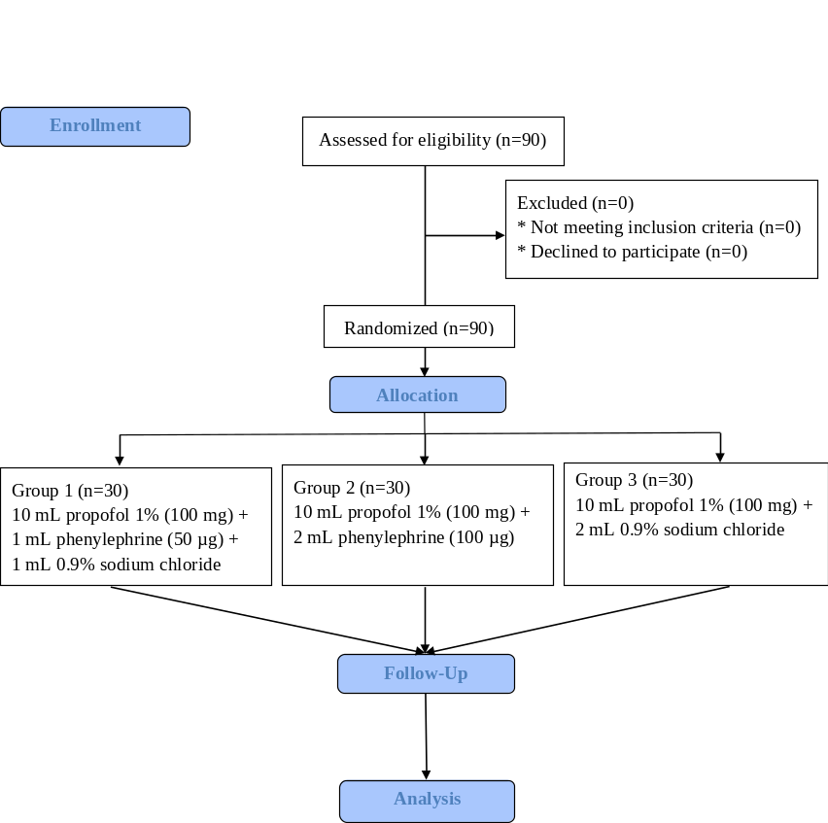
Data were analyzed using SPSS version 22.0 (IBM Corp., Armonk, NY, USA). Continuous variables were presented as mean ± standard deviation (SD), while categorical variables were expressed as frequencies and percentages (n, %). The normality of continuous variables was verified using the Shapiro-Wilk test. To assess the comparability of the three groups at baseline, one-way ANOVA was utilized for continuous variables; if a significant difference was found, Tukey’s HSD post-hoc test was performed for pairwise comparisons. For categorical data, the Chi-square test was employed. When the Chi-square test yielded a significant result (p < 0.05), post-hoc pairwise comparisons of column proportions were conducted with Bonferroni correction to identify specific differences between groups. For hemodynamic parameters (SBP, DBP, MAP, and HR) measured
repeatedly across seven time points (T0–T6), a two-way repeated-measures ANOVA was applied to evaluate the effects of group, time, and their interaction. Mauchly's test was used to assess the assumption of sphericity, and Greenhouse-Geisser corrections were applied if violated. When a statistically significant interaction was detected, post-hoc multiple comparisons with Bonferroni correction were performed to identify specific differences between groups at each measurement interval. Differences were considered statistically significant at P < 0.05.
3. RESULTS
Figure 1: CONSORT study flow diagram
Total of 90 elderly patients were enrolled, randomized, and completed the study, with 30 participants assigned to each group (Figure 1). Baseline demographic and clinical characteristics were comparable across groups, with no significant differences in age, sex, body weight, comorbidities, ASA physical status, or duration of anesthesia (all p > 0.05) (Table 1), indicating good comparability of the study population.
The incidence of post-induction hypotension differed significantly among the groups (P = 0.001; Table 3). The control group (Group 3) reported the highest incidence (83.3%), followed by Group 1 (63.3%) while Group 2 had the lowest rate (36.7%). Post-hoc analysis demonstrated that hypotension occurred significantly less frequently in Group 2 than in Group 3 (P < 0.05), whereas Group 1 showed an intermediate incidence and did not differ significantly from either group. A similar pattern was observed for hypotension requiring treatment, with a significant difference among groups (P < 0.001). The incidence of
hypotension requiring treatment was lowest in Group 2 (20.0%) and highest in Group 3 (76.7%), with post-hoc analysis confirming a significant difference between these two groups (P < 0.05). Group 1 again demonstrated an intermediate rate (46.7%), without a statistically significant difference compared with either Group 2 or Group 3.
Two-way repeated-measures ANOVA demonstrated a significant group × time interaction for SBP, DBP, and MAP (all P < 0.001; Figure 2, 3, 4). While no significant differences were observed at baseline or immediately after induction (T0-T2), blood pressure values in Group 3 dropped significantly lower than the intervention groups between T3 and T5.
T3 (one minute post-LMA insertion), the point of maximum decline, MAP and SBP in Group 3 were significantly lower than in both Group 1 (P = 0.002 for MAP; P < 0.001 for SBP) and Group 2 (P < 0.001 for both). At T4 (three minutes post-LMA), Group 2 maintained superior stability with MAP and SBP significantly higher than Group 3 (P = 0.002 and P < 0.001, respectively). In contrast, the difference between Group 1 and Group 3 failed to reach statistical significance at T4 (P = 0.072 for MAP; P = 0.071 for SBP).
For HR, two-way repeated-measures ANOVA showed no significant group × time interaction (P = 0.103; Figure 5). A significant main effect of time was observ ed (P < 0.001), reflecting a general downward trend in all groups, but there were no significant intergroup differences at any measurement point.
The induction doses of propofol (range: 1.52–1.53 mg/kg) and fentanyl were comparable across all three groups (P > 0.05; Table 4). Although Group 2 received
Table 1: Demographics and surgical information
Characteristics | Group 1  (n = 30) | Group 2  (n = 30) | Group 3  (n = 30) | P-value
Age (years) | 75.57 ± 7.83 | 78.13 ± 10.63 | 73.90 ± 9.21 | 0.212*
Age group classification according to WHO
60-74 (years) | 14 (46.7%) | 11 (36.7%) | 17 (56.7%) | 0.66#
74-84 (years) | 11 (36.7%) | 13 (43.3%) | 9 (30%) | 0.66#
Over 84 (years) | 5 (16.6%) | 6 (20%) | 4 (13.3%) | 0.66#
Gender (Male) | 15 (50%) | 15 (50%) | 14 (46.7%) | 0.957#
Weight (kg) | 52.07 ± 11.46 | 51.37 ± 9.98 | 52.93 ± 11.59 | 0.859*
Comorbidities
Hypertension | 17 (56.7%) | 20 (66.7%) | 16 (53.3%) | 0.551#
Diabetes | 16 (53.3%) | 10 (33.3%) | 11 (36.7%) | 0.241#
Cerebral stroke | 5 (16.7%) | 10 (33.3%) | 4 (13.3%) | 0.126#
ASA status
ASA II | 13 (43.3%) | 9 (30%) | 12 (40%) | 0.541#
ASA III | 17 (56.7%) | 21 (70%) | 18 (60%) | 0.541#
Duration of anesthesia (min) | 112.77 ± 8.91 | 112.87 ± 8.66 | 111.07 ± 7.94 | 0.572*
^{(*)} One-way ANOVA test, ^{(#)} Chi- square test; P < 0.05 considered as significant

Table 3: Medications and doses used during induction
Medication  (X ± SD) | Group 1  (n = 30) | Group 2  (n = 30) | Group 3  (n = 30) | p-value
Initial propofol (mg) | 78.67 ± 14.32 | 78.00 ± 15.01 | 79.67 ± 14.20 | 0.905*
Initial propofol dosage/kg | 1.53 ± 0.09 | 1.52 ± 0.08 | 1.52 ± 0.11 | 0.901*
Initial fentanyl (µg) | 105.67 ± 22.39 | 103.67 ± 19.03 | 105.33 ± 22.85 | 0.928*
Initial phenylephrine (µg) | 39.33 ± 7.16ª | 78.00 ± 15.01^{b} | 0.00 ± 0.00^{c} | < 0.001*
Supplemental phenylephrine (µg) | 61.67 ± 75.07^{a,b} | 21.67 ± 44.88ª | 101.67 ± 77.11^{b} | <0.001*
Total phenylephrine (µg) | 101.0 ± 73.55 | 99.67 ± 44.93 | 101.67 ± 77.11 | 0.993*
^{(*)} One-way ANOVA test; For variables with p < 0.05, different superscript letters (^{a,b,c}) indicate significant differences between groups based on post-hoc comparisons.
Table 2. Hypotension and of hypotension requiring treatment
Outcomes | Group 1  (n = 30) | Group 2  (n = 30) | Group 3  (n = 30) | p-value
Hypotension | 19 (63.3%)^{a,b} | 11 (36.7%)ª | 25 (83,3%)^{b} | 0.001#
Hypotension requiring treatment | 14 (46.7%)^{a,b} | 6 (20%)ª | 23 (76.7%)^{b} | <0.001#
(#) Chi- square test;
For variables with p<0.05, different superscript letters (^{a ,b}) indicate significant differences between groups based on post-hoc comparisons.

a higher initial preventive dose of phenylephrine (78.00 ± 15.01 µg) compared to Group 1 (39.33 ± 7.16 µg), the total cumulative dose of phenylephrine (preventive plus rescue boluses) was statistically similar across all

groups, averaging approximately 100 µg (P = 0.993). The requirement for supplemental (rescue) phenylephrine to manage hypotensive episodes (defined as MAP < 60 mmHg) showed significant intergroup
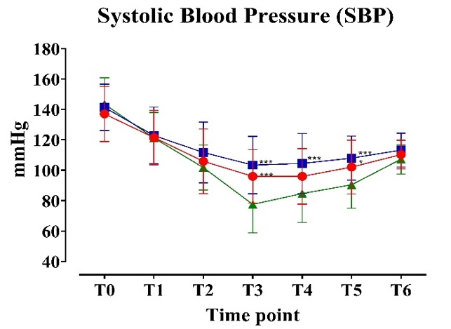

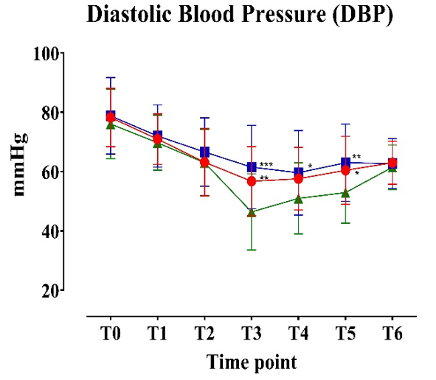

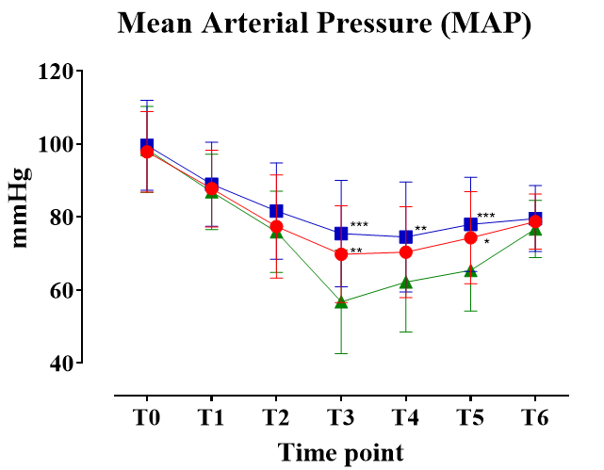
Figure: Systolic, diastolic anf mean BP in the three groups at fixed time points

(*P < 0.05, **P < 0.01, ***P < 0.001).

differences (P < 0.001). Group 2 required a significantly lower rescue dose (21.67 ± 44.88 µg ª) compared to the control group (Group 3), which required the highest amount (101.67 ± 77.11 µg^{b}, P < 0.001). Group 1 occupied an intermediate position, requiring a mean rescue dose of 61.67 ± 75.07 µg^{a,b}.
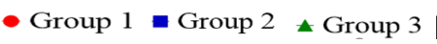
According to the post-hoc analysis, Group 1 did not how a statistically significant difference from either Group 2 or Group 3 (sharing superscripts ª and ^{b}.
4. DISCUSSION
This randomized, double-blind controlled trial was conducted to evaluate the prophylactic efficacy of combining different doses of phenylephrine with propofol in reducing induction-related hypotension during anesthetic induction and LMA insertion in elderly patients. Successful randomization resulted in well-balanced study groups with respect to baseline demographic and clinical characteristics, including age
distribution, sex, body weight, comorbidity burden, ASA physical status, and anesthetic duration. This baseline comparability strengthens the internal validity of the trial and supports the interpretation that observed hemodynamic differences were attributable to the phenylephrine preparation strategy rather than underlying patient-related confounders.
Our findings suggest an increased susceptibility to propofol-induced hypotension in this high-risk elderly population. This tendency is reflected in the high incidence observed in the control group, indicating that propofol induction in elderly patients may represent a considerable hemodynamic challenge.
The incidence observed in our control group appears higher than that reported in several previous studies involving elderly patients, including the 73.2% reported by Chunyan Zhou et al. (2025),¹⁶ the 60% baseline described by Farhan M. et al. (2015),⁸ and the 43.33% reported by Ahsan Amjad (2025).¹⁷ In addition, the rate in our study exceeded those reported in studies involving younger populations, such as the 51% reported by Imran M. et al. (2007), whose control group had a mean age of 33.84 ± 10.11 years,¹⁵ and the 16.24% reported by Jigna Shah (2019), with a mean age of 44.5 ± 9.01 years.¹⁸
The relatively high incidence observed in the present study may be related to the vulnerable characteristics of our cohort, including advanced age (mean age >73 years), a high proportion of ASA III patients, and the use of LMA insertion, which is associated with less sympathetic stimulation than tracheal intubation.¹⁹ Hypotension was most frequently observed between the first and third minute after LMA insertion (T3–T4), corresponding to the period of maximal cardiovascular depressant effects of propofol. Taken together, these findings imply that dose titration and slow injection techniques alone may not be sufficient to fully mitigate induction-related hypotension in elderly patients.
The present study suggests that prophylactic administration of phenylephrine in combination with propofol may reduce the incidence of induction-related hypotension, as defined by a decrease in systolic blood pressure exceeding 30% from baseline. Among the evaluated doses, the 100 µg phenylephrine regimen (Group 2) was associated with a lower incidence of hypotension (36.7%) and hypotension requiring treatment (20%) compared with the control group, with statistically significant differences observed. In contrast, the 50 µg dose (Group 1) demonstrated an intermediate effect, with an overall hypotension rate of 63.3%, and did not differ significantly from the control group in post-hoc analysis, suggesting that this lower dose may provide limited prophylactic benefit in this elderly population.
These findings are broadly consistent with previous dose-finding studies. Imran M. et al. reported a reduction in hypotension to 20% with a 100 µg dose, whereas the 50 µg dose remained less effective (56%).¹⁵ Similar trends were observed by Vo Van Hien (2023), who reported hypotension rates of 20% and 48% for the 100 µg and 50 µg doses, respectively.²⁰ Farhan M. et al. demonstrated a reduction from 60% in the control group to 24.4% with 100 µg phenylephrine while Ahsan Amjad (2025) reported complete prevention of hypotension in the 100 µg group compared with 43.33% in controls.^{8, 17} These data suggest that a 100 µg prophylactic dose may offer more consistent hemodynamic protection in elderly patients.
Analysis of secondary outcomes further supports this observation. Two-way repeated-measures ANOVA demonstrated a significant group × time interaction for SBP, DBP, and MAP (p < 0.001), indicating differential hemodynamic responses among the study groups over time. Although blood pressure declined in all groups following induction-reflecting the known vasodilatory effects of propofol-the magnitude and duration of hypotension differed. At the time of maximal blood pressure reduction (T3), the control group exhibited significantly lower SBP and MAP compared with both intervention groups. By T4, only the 100 µg phenylephrine-group maintained MAP values significantly higher than the control group, whereas the 50 µg group no longer differed significantly, suggesting a more sustained stabilizing effect with the higher prophylactic dose. Maintaining hemodynamic stability is paramount in elderly patients to ensure adequate perfusion of vital organs, such as the brain and kidneys, thereby reducing the independent risk of perioperative organ ischemia and subsequent morbidity/mortality.^{5, 21}
With respect to vasopressor consumption, although Group 2 received a higher initial preventive amount of phenylephrine, the total cumulative phenylephrine dose administered during the induction period did not differ significantly among groups (approximately 100 µg). Notably, in the control group, the majority of phenylephrine was administered as rescue treatment after hypotension had already developed, whereas in Group 2, supplemental phenylephrine requirements were significantly lower. This finding suggests that early prophylactic administration may reduce the depth and duration of hypotension, rather than increasing overall vasopressor exposure.
Phenylephrine acts primarily as a selective α1 -adrenergic agonist, increasing blood pressure through peripheral vasoconstriction, minimizing effects on chronotropy and inotropy.²¹ Concerns regarding reflex bradycardia following phenylephrine administration were addressed. Our results showed no statistically significant difference in HR changes among the three groups at any measurement point (p > 0.05). This stability is attributed to the low, frequently recommended dosage of phenylephrine utilized. Importantly, Kamenik et al. (2020) noted that reflex bradycardia requiring treatment with Atropine occurred in 9.5% of their intervention group,²² while Kwok F.Y. et al. (2016) reported a rate of 4.2%.¹⁴ Our results, showing no adverse effects on HR, support the safety and efficacy of a 100 µg phenylephrine dose in this setting, balancing vasoconstrictive necessity with minimal chronotropic risk.
5. LIMITATIONS
Despite achieving its primary objectives, this study has several limitations inherent to its design and study population. First, the study was conducted as a single-center trial, which may limit the generalizability of the findings to the broader elderly patient population. Second, the patient cohort was confined to individuals undergoing flap transfer for chronic ulcers, and the specific pathophysiological characteristics of this group may differ from those of elderly patients undergoing other types of major surgery. Third, the study utilized intermittent non-invasive blood pressure (NIBP) measurements at one-minute intervals. This measurement method may have missed rapid, transient hemodynamic fluctuations, such as beat-to-beat variability, that could be detected using continuous invasive blood pressure (IBP) monitoring. Fourth, although patient comorbidities (e.g., hypertension and diabetes mellitus) were recorded, the severity and degree of disease control were not analyzed, which may have acted as potential confounding factors influencing hemodynamic responses.
6. CONCLUSION
This study suggests that hypotension is a common complication following propofol induction and LMA insertion in elderly patients. Co-administration of phenylephrine at a dose of 100 µg with propofol was associated with a lower incidence of hypotension and hypotension requiring treatment compared with a 50 µg dose or propofol alone. The 100 µg admixture provided improved hemodynamic stability during induction without clinically significant effects on heart rate. Notably, total phenylephrine consumption during induction was similar across groups, indicating that early preventive administration of an effective dose may be more beneficial than reactive treatment alone. These findings support the use of a phenylephrine–propofol admixture as a practical strategy to reduce induction-related hypotension during LMA anesthesia in elderly patients.
7. Data availability
The numerical data generated during this research are available from the authors.
8. Conflict of interest
All authors declare that there was no conflict of interest.
9. Funding
The study utilized the hospital resources only, and no external or industry funding was involved.
10. Authors’ contribution
HVV: Conceptualized the study, designed the methodology, collected and analysed the data, and drafted the manuscript.
QVN: Contributed to study design, collected and analysed the data, and drafted the manuscript.
TXV: NL: HPT: Collected and analysed the data and contributed to drafting the manuscript.
11, REFERENCES
- Olotu C. Anesthesia for the elderly: a narrative review. Minerva Anestesiol. 2021;87(10):1128-1138. DOI: https://doi.org/10.23736/s0375-9393.21.15388-x
- Yang R, Wolfson M, Lewis MC. Unique aspects of the elderly surgical population: an anesthesiologist's perspective. Geriatr Orthop Surg Rehabil. 2011;2(2):56-64. DOI: https://doi.org/10.1177/2151458510394606
- Aceto P, Antonelli IR, Bettelli G, Carron M, Chiumiento F, Corcione A, et al. Perioperative management of elderly patients (PriME): recommendations from an Italian intersociety consensus. Aging Clin Exp Res. 2020;32:1647-1673. DOI: https://doi.org/10.1007/s40520-020-01624-x
- Kanonidou Z, Karystianou G. Anesthesia for the elderly. Hippokratia. 2007;11(4):175-177.
- Amornyotin S. Anesthetic consideration for geriatric patients. In: Anesthesia and perioperative care for elderly patients. IntechOpen. 2021. DOI: https://doi.org/10.5772/intechopen.97003
- Claeys MA, Gepts E, Camu F. Haemodynamic changes during anaesthesia induced and maintained with propofol. Br J Anaesth. 1988;60(1):3-9. DOI: https://doi.org/10.1093/bja/60.1.3
- Larsen R, Rathgeber J, Bagdahn A, Lange H, Rieke H. Effects of propofol on cardiovascular dynamics and coronary blood flow in geriatric patients. A comparison with etomidate. Anaesthesia. 1988;43 Suppl:25-31. DOI: https://doi.org/10.1111/j.1365-2044.1988.tb09064.x
- Farhan M, Hoda MQ, Ullah H. Prevention of hypotension associated with the induction dose of propofol: a randomized controlled trial comparing equipotent doses of phenylephrine and ephedrine. J Anaesthesiol Clin Pharmacol. 2015;31(4):526-530. DOI: https://doi.org/10.4103/0970-9185.169083
- Takaki R, Yokose M, Mihara T, Saigusa Y, Tanaka H, Yamamoto N, et al. Hypotension after general anaesthesia induction using remimazolam or propofol in geriatric patients undergoing sevoflurane anaesthesia with remifentanil: a single-centre, double-blind, randomised controlled trial. Br J Anaesth. 2024;133(1):24-32. DOI: https://doi.org/10.1016/j.bja.2024.04.013
- Reich DL, Hossain S, Krol M, Baez B, Patel P, Bernstein A, et al. Predictors of hypotension after induction of general anesthesia. Anesth Analg. 2005;101(3):622-628. DOI: https://doi.org/10.1213/01.ANE.0000175214.38450.91
- Zhao B, Chen X, Chen Q, Li G, Chen Z, Yang Z, et al. Intraoperative hypotension and related risk factors for postoperative mortality after noncardiac surgery in elderly patients: a retrospective analysis report. Clin Interv Aging. 2021;16:1757-1767. DOI: https://doi.org/10.2147/CIA.S327311
- Kore S, Vyas V, Dandawate P, Choudhary N, C H, Shah J. A comparative study of ephedrine and phenylephrine to counteract propofol induced hypotension. Int J Acad Med Pharm. 2023;5(4):1304-1310.
- Dutta V. Prevention of hypotension during induction of anesthesia with propofol and fentanyl: Comparison of preloading with crystalloid and intravenous ephedrine. IOSR J Dent Med Sci. 2012;1(1):26-30. DOI: https://doi.org/10.9790/0853-0112630
- Kwok FY, Venugobal S. The effect of prophylactic phenylephrine on systemic hypotension during induction of anaesthesia with propofol in patients over 55 years old. Med J Malaysia. 2016;71(4):166-170.
- Imran M, Khan FH, Khan MA. Attenuation of hypotension using phenylephrine during induction of anaesthesia with propofol. J Pak Med Assoc. 2007;57(11):537-543.
- Zhou C, Wang X, Zhou M, Guo S, Qi Y, Sun J, et al. Comparison of remimazolam and propofol on post-induction hypotension in elderly hypertensive patients: a randomized controlled trial. Drug Des Devel Ther. 2025;19:3425-3435. DOI: https://doi.org/10.2147/DDDT.S510431
- Amjad A, Gul S, Tahseen T, Tariq Z, Qureshi AM, Afzal SJ, et al. Comparison of frequency of hypotension with prophylactic phenylephrine versus placebo in patients undergoing induction of general anaesthesia with propofol. MedERA. 2025;7(2). DOI: https://doi.org/10.61982/medera.v7i2.390
- Shah J, Patel I, Guha A. Comparative study of propofol versus etomidate as an induction agent to evaluate hemodynamic changes during induction of anesthesia in controlled hypertensive patients. J Anaesth Pain Intensive Care. 2018;22(3):361-367.
- Liao H, Chen L, Sheng C. The effects of on hemodynamics, oxygen saturation, peak airway pressure and adverse events during anesthesia for thyroid surgery: tracheal intubation Vs. ProSeal laryngeal mask airway. Am J Transl Res. 2021;13(4):2738-2744.
- Hien VV. Effectiveness of phenylephrine in preventing hypotension after propofol induction for burn eschar excision and skin grafting surgery. Mil Med Pharm J. 2023;48(9):86-94. DOI: https://doi.org/10.56535/jmpm.v48i9.530
- White M, Fourney A, Mikes E, Leenen FH. Effects of age and hypertension on cardiac responses to the alpha1-agonist phenylephrine in humans. Am J Hypertens. 1999;12(2 Pt 1):151-158. DOI: https://doi.org/10.1016/S0895-7061(98)00220-9
- Kamenik M, Kos D, Möller Petrun A, Green DW, Zorko N, Mekiš D. Haemodynamic stability during anaesthesia induction with propofol: impact of phenylephrine. A double-blind, randomised clinical trial. Signa Vitae. 2018;14(1):20-26. DOI: https://doi.org/10.22514/SV141.052018.3

